## 5.Accordion

An **html** file is given and your task is to show **more**/**less** information for the selected article. At the start you should do a **GET** request to the server at adress: **http://localhost:3030/jsonstore/advanced/articles/list** where the response will be an object with the titles of the articles.

By clicking the **[More] button** for the selected **article**, it should **reveal** the content of a **hidden** div and **changes** the text of the button to **[Less]**. Obtain the content by making a **GET** request to the server at adress: **http://localhost:3030/jsonstore/advanced/articles/details/:id** where the response will be an object with property **id**, **title**, **content.** When the same button is clicked **again** (now reading **Less**), **hide** the div and **change** the text of the button to **More**. Link action should be **toggleable** (you should be able to click the button infinite amount of times).

**Example** 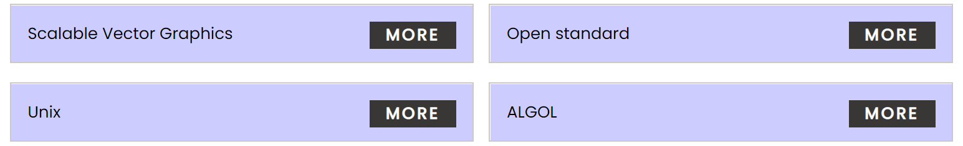

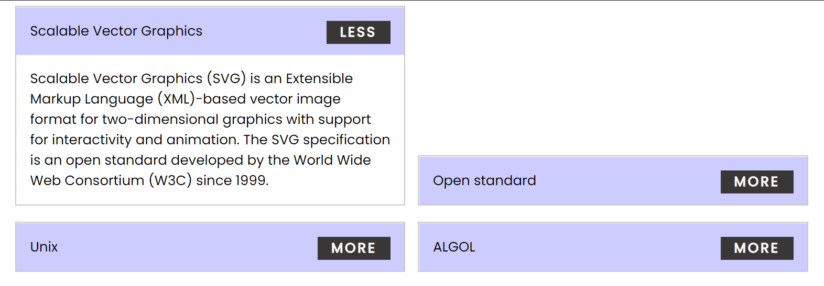

Every item should have the **following structure**:

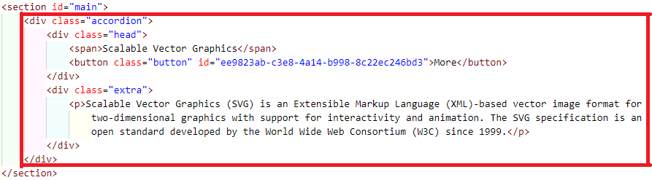

You are allowed to add new attributes, but do not change the existing ones.